Computer Networks
Complex Computing Problem
Section: V2

Members:
Zainab Imran F2024266205
Mariam Amin F 2024266274

Presented To: Sir. Dr. Naeem Ahmad

Problem Statement: Design of an Efficient IP Addressing and Subnetting Scheme for a University
Network
You have been hired as a network consultant for a mid-sized university. The university has eight
departments and blocks that need to be connected through a well-planned network:
• Departments and Blocks: Computer Science (CS), Software Engineering (SE), Informatics
Systems (INFS), Civil Engineering, Admin Office, Library, Faculty Block, and Hostel.
Each department requires a different size of network — large, medium, or small — depending on the
number of users (students, staff, and devices) and anticipated future growth.
The university has been assigned a single IP block: 192.168.0.0/22, which includes 1024 total IP
addresses. Your job is to design an efficient IP addressing and subnetting plan for this network.

1.1 Binary and Decimal Representation
IP version 4 (IPv4) addresses consist of 32 bits, expressed as four 8-bit octets in dotted-decimal notation. Each
octet ranges from 0 to 255. The conversion between binary and decimal is fundamental to subnetting.

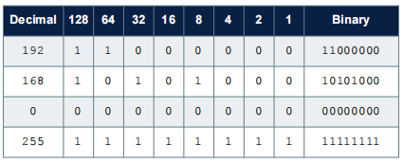

1.2 IP Addresses
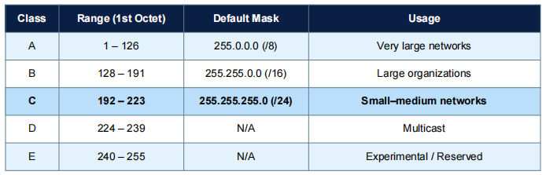

1.3 Private vs. Public IP Addresses
RFC 1918 reserves three ranges exclusively for private (internal) use, which are not routed on the public Internet.
The university network uses 192.168.0.0/22, which falls in the Class C private range
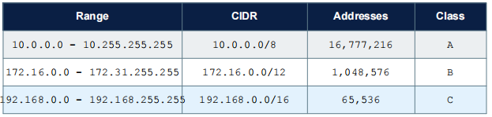

Phase 2: Subnetting Basics
Number of subnets 2^n
Hosts per subnets 2^h - 2
Network address Bitwise AND of IP address with subnet mask
Broadcast address Network address OR (inverse of subnet mask

2.3 Worked Example: /24 Subnet
To illustrate the calculation process for the Computer Science department (assigned 192.168.0.0/24):
IP block: 192.168.0.0
Prefix: /24
Host bits: 32 - 24 = 8
Total addresses: 2^8 = 256
Usable hosts: 2^8 - 2 = 254
Network address: 192.168.0.0
Broadcast address: 192.168.0.255
First usable host: 192.168.0.1
Last usable host: 192.168.0.254
Subnet mask: 255.255.255.0

3. VLSM Implementation — Department Subnets
Variable Length Subnet Masking (VLSM) allows each department to receive a subnet tailored exactly to its needs.
Subnets are allocated in decreasing order of size to prevent fragmentation of the address space.
Large (Up to 250 devices): Computer Science (CS), Hostel
· Medium (Up to 120 devices): Software Engineering (SE), Informatics Systems (INFS), Library
· Small (Up to 60 devices): Civil Engineering, Faculty Block, Admin Office
Department | Subnet ID | Subnet Mask | Usable IP Address Range | Broadcast Address | Valid Hosts
CS | 192.168.0.0 | /24 (255.255.255.0) | 192.168.0.1 - 192.168.0.254 | 192.168.0.255 | 254
Hostel | 192.168.1.0 | /24 (255.255.255.0) | 192.168.1.1 - 192.168.1.254 | 192.168.1.255 | 254
SE | 192.168.2.0 | /25 (255.255.255.128) | 192.168.2.1 - 192.168.2.126 | 192.168.2.127 | 126
INFS | 192.168.2.128 | /25 (255.255.255.128) | 192.168.2.129 - 192.168.2.254 | 192.168.2.255 | 126
Library | 192.168.3.0 | /25 (255.255.255.128) | 192.168.3.1 - 192.168.3.126 | 192.168.3.127 | 126
Civil Eng. | 192.168.3.128 | /26 (255.255.255.192) | 192.168.3.129 - 192.168.3.190 | 192.168.3.191 | 62
Faculty | 192.168.3.192 | /26 (255.255.255.192) | 192.168.3.193 - 192.168.3.254 | 192.168.3.255 | 62
Admin | 192.168.4.0 | /27 (255.255.255.224) | 192.168.4.1 - 192.168.4.30 | 192.168.4.31

- Subnetting Strategy & Justification
- IP Conservation: A standard Class C network (/24) for every department would waste hundreds of unused addresses. VLSM allows the allocation of smaller masks (like /26 or /27) tailored exactly to smaller departments like the Admin Office.
- Scalability: The address block from 192.168.4.32 to 192.168.4.255 remains unassigned, creating a pool of available IP addresses. This reserved space is perfect for accommodating future university growth, new buildings, or point-to-point router links.
- Broadcast Isolation: Segmenting the /22 block into smaller CIDR blocks minimizes unnecessary broadcast traffic, boosting the overall speed and security of the university network.
5. Planning for Growth & Scalability
5.1 Reserved Address Block
Reserved Block: 192.168.3.80 – 192.168.3.255 (176 addresses = 17.2% of total space)
This contiguous block can accommodate two new /27 subnets (30 hosts each), four /28 subnets (14 hosts
each), or one /25 subnet (126 hosts) for a future department.

5.2 Growth Strategies
Strategy 1 — Staged Subnet Release:
Allocate subnets from the reserved block only when a department formally requests additional capacity. This
avoids premature commitment of address space.
Strategy 2 — Supernetting / Route Aggregation:
If the /22 block is exhausted, request an additional contiguous block (e.g., 192.168.4.0/22) from the ISP and
aggregate both into a /21 for routing efficiency.
Strategy 3 — DHCP Dynamic Allocation:
Use DHCP servers with short lease times in high-turnover subnets (Hostel, Library) to maximize host-address
reuse within existing subnets.
Strategy 4 — IPv6 Dual-Stack Transition:
Plan for IPv6 adoption by assigning /64 IPv6 prefixes to each department in parallel, eliminating IPv4 address
exhaustion concerns long-term.
Strategy 5 — VLAN Segmentation:
Use VLANs to segment traffic within large subnets (CS, Hostel) without consuming extra IP space ,separating
IoT devices, student laptops, and lab equipment logically.

Conclusion: Why VLSM Was Chosen
With eight departments ranging from 15 to 250 users, a fixed /24 for all would consume 8 × 256 = 2,048 addresses double the available space. VLSM allows all departments to coexist within the 1,024-address /22 block with 176 addresses still available for growth.

